Project Title
_______________________________

Submitted by
Student Name (Program-Roll#-Section)
Student Name (Program-Roll#-Section)

Session 2020-2024

Supervised by
Teacher Name



Department of Computer Science
Lahore Garrison University
Lahore

Project Title

A project submitted to the
Department of Computer Science
In
Partial Fulfillment of the Requirements for the
Bachelor’s / Master Degree in Computer Science
By
Student Names

Internal Supervisor
Teacher Name _______________________
Designation
Department of Computer Science

External Examiner _______________________

Chairperson
Dr. Muhammad Kashif Siddhu _______________________
Assistant Professor
Department of Computer Science

COPYRIGHTS
This is to certify that the project titled “Terra Alert” is the genuine work carried out by Student Names, student of BSCS of Computer Science Department, Lahore Garrison University, Lahore during the academic year 2015-19, in partial fulfilment of the requirements for the award of the degree of Bachelor of Computer Science and that the project has not formed the basis for the award previously of any other degree, diploma, fellowship or any other similar title.

Student Name ____________

Student Name ___________

DECLARATION
This is to declare that the project entitled “Terra Alert” is an original work done by undersigned, in partial fulfilment of the requirements for the degree “Bachelor of Science in Computer Science” at Computer Science Department, Lahore Garrison University, Lahore.
All the analysis, design and system development have been accomplished by the undersigned. Moreover, this project has not been submitted to any other college or university.

Group Members
Student Name ________________
Student Name ________________
Student Name ________________
Student Name ________________
Supervisor

Supervisor Name ________________

Date: ________________

DEDICATION

ACKNOWLEDGEMENTS

Table of Contents
INTRODUCTION 16
1.1 Background of the Study 16
1.2 Project Context and Motivation 16
1.3 Unmet Need and Problem Relevance 16
1.4 Aim of the Project 17
1.5 Intended Users 17
1.6 Project Objectives 17
1.7 Significance of the Study 18
1.8 Scope Overview 18
1.9 Report Organization 18
1.10 Chapter Summary 18
LITERATURE REVIEW 19
2.1 Introduction to the Review 19
2.2 Disaster Risk Reduction and Early Warning Systems 19
2.3 Public Alerting Standards and Structured Warning Exchange 19
2.4 Earthquake and Weather Data Services as Public Information Sources 20
2.5 Information Fragmentation and Alert Fatigue 20
2.6 Machine Learning for Text Classification in Risk Contexts 20
2.7 Related Approaches to Web-Based Hazard Dashboards 21
2.8 Software Engineering Foundations Relevant to the Project 21
2.9 Database Design and Persistence Considerations 21
2.10 Critical Comparison of Existing Options 21
2.11 Research Gap 22
2.12 Chapter Summary 22
PROBLEM DEFINITION 23
3.1 Problem Background 23
3.2 Real-World Problem 23
3.3 Technical Problem 23
3.4 Stakeholders Affected 24
3.5 Limitations of Current Approaches 24
3.6 Formal Statement of the Problem 24
3.7 Project Objectives Derived from the Problem 24
3.8 Scope Boundaries of the Problem Solution 24
3.9 Chapter Summary 25
SOFTWARE REQUIREMENT SPECIFICATION 26
4.1 Introduction to the SRS 26
4.2 User Classes and Characteristics 26
4.3 Functional Requirements 26
4.4 Non-Functional Requirements 27
4.5 System Requirements 28
4.6 Assumptions 29
4.7 Constraints 29
4.8 Input and Output Requirements 29
4.9 Use-Case Oriented Requirements Explanation 29
4.10 Chapter Summary 30
METHODOLOGY 31
5.1 Methodological Overview 31
5.2 Development Approach 31
5.3 Rationale for Tool Selection 31
5.4 Data Collection Methodology 32
5.5 Machine Learning Methodology 32
5.6 Risk Assessment Methodology 32
5.7 Alert Generation Methodology 33
5.8 User Interface Methodology 33
5.9 Testing and Validation Methodology 34
5.10 Limitations of the Methodology 34
5.11 Chapter Summary 34
DETAILED DESIGN AND ARCHITECTURE 35
6.1 System Architecture 35
6.1.1 Architecture Design Approach 35
6.1.2 Architecture Design 35
6.1.3 Subsystem Architecture 36
6.2 DETAILED SYSTEM DESIGN 37
6.2.1 Classification 37
6.2.2 Definition 37
6.2.3 Responsibilities 38
6.2.4 Constraints 38
6.2.5 Composition 38
6.2.6 Uses/Interactions 38
6.2.7 Resources 39
6.2.8 Processing 39
6.2.9 Interface/Exports 40
6.3 Chapter Summary 42
IMPLEMENTATION AND TESTING 43
7.1 Implementation Environment 43
7.2 Core Implementation Strategy 43
7.3 Backend Implementation 43
7.4 Frontend Implementation 43
7.5 Machine Learning Implementation 44
7.6 Database Implementation 44
7.7 Error Handling and Validation 44
7.8 Testing Strategy 44
7.9 Representative Test Cases 45
7.10 Accuracy, Performance, and Scalability Analysis 45
7.11 Comparison Against Original Specifications 45
7.12 Chapter Summary 45
RESULTS AND DISCUSSION 49
8.1 Evaluation Overview 49
8.2 Functional Results 49
8.3 Behavior of the Risk Model 49
8.4 Discussion of Classification Results 50
8.5 User-Facing Discussion 50
8.6 Requirement Coverage Discussion 50
8.7 Strengths of the Proposed Solution 51
8.8 Weaknesses and Limitations 51
8.9 Test Coverage and Use-Case Coverage 51
8.10 Overall Interpretation 51
8.11 Chapter Summary 52
CONCLUSION AND FUTURE WORK 53
9.1 Conclusion 53
9.2 Achievement of Objectives 53
9.3 Evidence That the Problem Was Addressed 53
9.4 Academic and Practical Contribution 54
9.5 Future Work 54
9.6 Final Remarks 55
REFERENCES 56

List of Tables
Table 1 - User Class 26
Table 2 - Functional Requirments 26
Table 3 - Non-Functional Requirments 27
Table 4 - External Data Sources Reference 28
Table 5 - Test Cases and Results 46
Table 6 - Test Results Summary by Module 51

List of Figures
Figure 1 - Risk Score Decay Formula 33
Figure 2 - System Architecture Diagram 36
Figure 3 - Sequence Diagram 37
Figure 4 - Component Diagram 39
Figure 5 - Use Case Diagram 40
Figure 6 - State Machine Diagram 42
Figure 7 - Deployment Diagram 42
Figure 8 - ER Diagram 42
Figure 9 - Risk Trend Diagram 51

List of Abbreviation
AI: Artificial Intelligence
AJAX: Asynchronous JavaScript and XML
API: Application Programming Interface
CDN: Content Delivery Network
CSS: Cascading Style Sheets
CSV: Comma-Separated Values
DB: Database
DFD: Data Flow Diagram
DIGD: Detected Information Gaps in Disasters
DOM: Document Object Model
ERD: Entity-Relationship Diagram
FYP: Final Year Project
GDACS: Global Disaster Alert and Coordination System
GUI: Graphical User Interface
HTML: HyperText Markup Language
HTTP: Hypertext Transfer Protocol
JSON: JavaScript Object Notation
JS: JavaScript
ML: Machine Learning
MVC: Model-View-Controller
NHC: National Hurricane Center
NLP: Natural Language Processing
NOAA: National Oceanic and Atmospheric Administration
NWS: National Weather Service
OSM: OpenStreetMap
REST: Representational State Transfer
RSS: Really Simple Syndication
SQL: Structured Query Language
SQLite: Structured Query Language (Lite)
SRS: Software Requirements Specification
SSR: Server-Side Rendering
TF-IDF: Term Frequency-Inverse Document Frequency
UML: Unified Modeling Language
USGS: United States Geological Survey
WSGI: Web Server Gateway Interface
XML: Extensible Markup Language

ABSTRACT
In the modern era, disasters no longer occur in a vacuum; instead, they unfold within a digital environment characterized by a staggering level of information overload, fragmented reporting channels, and a persistent inequality in how the public accesses timely risk interpretation. Although credible global and local agencies publish earthquake, weather, and general hazard information almost continuously, this data is often trapped in heterogeneous formats and isolated across separate platforms. This fragmentation makes it incredibly difficult for ordinary citizens and local responders to synthesize a clear, localized, and current understanding of the danger they face. This Final Year Project, titled "Terra Alert: AI-Assisted Disaster Risk Awareness and Management System," directly addresses this critical gap through the design and implementation of a comprehensive, web-based disaster risk awareness and management system. By aggregating multi-source incident data and classifying unstructured textual reports with a lightweight but effective machine learning pipeline, the system transforms raw data into actionable intelligence. At its core, the platform computes a dynamic, decaying risk probability score and presents it through an accessible, user-friendly dashboard that prioritizes actionable alerts and practical precautions for the end user.
The technical architecture of the proposed system follows a service-oriented monolithic approach, built using the Python and Flask ecosystem to ensure both stability and ease of deployment. The system functions by integrating external data feeds from professional disaster-monitoring agencies, normalizing these incoming records into a unified format to ensure consistency across the board. To handle the classification of disaster events, the pipeline applies term-frequency inverse-document-frequency (TF-IDF) based text representation combined with a logistic regression classification model. This allows the system to accurately categorize reports into specific disaster types without the overhead of overly complex infrastructure. A unique and vital feature of this system is the introduction of an exponential time-decay model. This mathematical approach is designed to avoid the common pitfall of presenting stale, older events as being just as urgent as current ones; it gradually reduces the influence of aging reports while ensuring that severe and recent incidents maintain their rightful priority in the risk calculation.
Structurally, the final platform is composed of several integrated modules responsible for data collection, classification, risk calculation, alert generation, and the persistence of historical alert data for future reference. It also includes a dedicated guidance display and basic administrative support systems that respect and save user preferences to create a more personalized experience. While the project scope is specifically focused on four primary disaster classes—earthquakes, floods, cyclones, and heatwaves—it intentionally excludes high-density live mapping and large-scale asynchronous notification infrastructure to maintain a lean and academically feasible version of the software. Evaluation of the system was conducted through a rigorous process of narrative functional validation, module-level analysis, route testing, and classifier workflow verification, alongside scenario-based testing of the risk calculations. These results demonstrate that even a compact software solution can successfully transform scattered, noisy disaster data into centralized and practically useful public-awareness intelligence. Ultimately, the project concludes that an integrated, AI-assisted approach significantly improves risk visibility and decision support, while offering a clear roadmap for future enhancements like richer geospatial intelligence and advanced contextual language models.

Chapter 1

INTRODUCTION

1.1 Background of the Study
Human societies have always lived under the constant influence of natural and environmental hazards, but the dawn of the digital age has fundamentally transformed both the sheer scale of available disaster information and the inherent complexity of interpreting it. In today’s hyper-connected world, citizens, relief organizations, and local administrators can theoretically access an unprecedented volume of hazard data through various websites, live feeds, and public application programming interfaces (APIs). However, in practice, this abundance of data has not automatically translated into a clearer understanding of danger for the average person. On the contrary, it often creates a "noise" problem where earthquake reports might emerge from one specialized system, weather advisories from another, and regional alerts from an entirely different platform—each expressed in conflicting technical formats and varying degrees of usability. This fragmentation places a significant cognitive burden on the end user, who is often expected to navigate multiple interfaces and manually interpret whether an incident is still relevant, how severe it truly is, and if it is geographically meaningful to them. Early warning and risk communication literature consistently emphasizes that useful disaster intelligence is not merely a matter of raw data availability; its true value depends on timeliness, interpretability, consistency, and, most importantly, the ability to support immediate, decisive action [1], [11], [12].

1.2 Project Context and Motivation
Terra Alert emerged from the direct recognition that while public safety information is frequently available, it is rarely integrated in a way that serves the common citizen. The project is a response to a very practical and pressing question: how can a modest but intelligently designed software system turn scattered, heterogeneous disaster feeds into a single, understandable view of local risk? The primary motivating concern behind this project is not just the problem of delayed awareness, but also the rising phenomenon of "alert fatigue." This is a dangerous condition where users are exposed to so many disconnected, repetitive, or irrelevant alerts that they eventually struggle to distinguish which ones actually deserve their immediate attention. Existing communication channels often announce the existence of a hazard in a vacuum, failing to explain how its urgency naturally declines over time or how a user should respond in simple, operational terms. Therefore, the motivation for Terra Alert: AI-Assisted Disaster Risk Awareness and Management System is both technical and social in nature. Technically, it seeks to unify the entire pipeline of feed ingestion, text classification, and risk scoring within a maintainable architecture. Socially, it aims to democratize access to high-level hazard awareness for ordinary users who may not have the specialized knowledge to decode complex meteorological or seismic data.

1.3 Unmet Need and Problem Relevance
The unmet need addressed by this project lies at the critical intersection of data integration, localized interpretation, and user-centric communication. While many professional agencies publish highly trustworthy hazard data, the general public still lacks a lightweight, "all-in-one" system that performs the heavy lifting of the disaster response workflow. Currently, there is a gap for a system that collects heterogeneous reports, standardizes them into a readable format, filters out irrelevant "noise," classifies loosely structured incident text, and then computes a meaningful risk summary—all while storing historical logs and displaying practical guidance alongside the alerts. This need is deeply relevant to a wide demographic, ranging from the general public and local residents to travelers who may find themselves temporarily exposed to unfamiliar and dangerous environments. It also serves local coordinators who need a synthesized overview of multiple ongoing threats without having to monitor dozens of sources simultaneously. From an academic perspective, the problem is equally relevant as it challenges the developer to combine software engineering, machine learning, database design, and web development into a single, coherent decision-support system.

1.4 Aim of the Project
The central aim of Terra Alert: AI-Assisted Disaster Risk Awareness and Management System is to design, develop, and evaluate a robust web-based platform capable of aggregating externally published hazard data and transforming it into a clear, prioritized safety tool. The project focuses on classifying incidents into meaningful categories, computing dynamic risk percentages that reflect real-time urgency, and presenting user-friendly warnings paired with specific precautionary guidance. It is important to note that this project does not seek to replace or compete with official emergency authorities; rather, it is designed to act as an intelligent interpretive layer. By doing so, it improves public understanding and makes critical safety information far more accessible to the people who need it most, when they need it most.

1.5 Intended Users
The proposed system is built to serve two primary categories of users, each with distinct needs for information. The first and most prominent category is the general public, which includes both permanent residents and temporary travelers who require a simple, fast mechanism to check current disaster risk conditions for their specific location. These users typically need immediate, "bottom-line" precautions rather than raw data. The second category consists of local administrators, community volunteers, and emergency responders. For these users, the system provides a condensed, high-level overview of active alerts synthesized from multiple external sources, helping them maintain situational awareness without being overwhelmed by technical feeds. In both instances, Terra Alert is designed for individuals who require interpretive support and clarity over raw, unorganized data streams.

1.6 Project Objectives
To achieve the overarching aim of the project, several specific and measurable objectives have been established. These include the automation of data ingestion from various heterogeneous disaster feeds and the successful classification of unstructured incident text using a dedicated machine learning pipeline. Furthermore, the project involves formulating and implementing a custom decaying risk calculation model to ensure that alerts remain relevant to the current moment. Other key objectives include the generation of understandable warnings and actionable safety guidance, the maintenance of a persistent historical ledger for auditing and future analysis, and the final delivery of these features through a responsive, intuitive web dashboard. Collectively, these objectives serve as the roadmap for translating a broad social problem into a set of implementable and testable software goals.

1.7 Significance of the Study
The significance of this study is twofold, offering both practical and academic value. First, it serves as a powerful demonstration of how a compact, academically-driven system can bridge a major information gap in public safety without the need for enterprise-scale, multi-million dollar infrastructure. It proves that smart logic and efficient design can solve big-world problems. Second, it highlights the immense value of combining traditional software engineering principles with applied machine learning in a socially meaningful context. By transforming fragmented, chaotic reports into risk-aware summaries, the project contributes to the broader global discussion on digital resilience and data-informed public safety. Furthermore, the system provides an excellent case study in designing maintainable service modules, applying lightweight natural language processing (NLP) methods, and integrating external data services in a responsible and ethical manner [4]–[7], [10], [15].

1.8 Scope Overview
The scope of the current version of Terra Alert is carefully defined to ensure a high-quality, functional implementation. It includes the ingestion of actively tracked disaster reports, the normalization of those records, and the classification of four specific hazard types: earthquakes, floods, cyclones, and heatwaves. The system also encompasses the storage of historical data, the display of calculated risk levels, and the presentation of safety guidance. To keep the project within the boundaries of a feasible undergraduate software engineering framework, certain high-complexity features have been deliberately excluded. These include live push notifications, high-density geospatial rendering, broad multilingual support, and the use of heavy deep-learning language models. These exclusions allow for a more focused and polished execution of the core interpretive engine that drives the system’s primary value.

1.9 Report Organization
This comprehensive report is organized into nine distinct chapters, each detailing a specific phase of the project's evolution. Chapter 1 sets the stage by introducing the domain, motivation, and objectives. Chapter 2 provides a deep dive into existing literature, examining the technologies and research that inform disaster awareness and text classification. Chapter 3 defines the problem analytically, establishing the specific "gap" that Terra Alert intends to fill. Chapter 4 documents the Software Requirement Specification (SRS), outlining exactly what the system must do from both a functional and technical standpoint. Chapter 5 explains the methodology, including the development approach and the algorithms used, while Chapter 6 details the architecture and design of the subsystems. Chapter 7 covers the actual implementation and the testing strategies used for validation. Chapter 8 presents the final results and a discussion of the outcomes, and finally, Chapter 9 concludes the report by summarizing the project's contributions and proposing a vision for future enhancements.

1.10 Chapter Summary
In summary, this introductory chapter has provided the necessary context for understanding the challenges of modern disaster information management. It has justified the urgent need for an integrated, AI-assisted awareness platform and clearly outlined the purpose, scope, and significance of the Terra Alert system. By establishing this foundation, the chapter prepares the reader for the following sections, which will build upon these ideas by reviewing relevant literature and technical frameworks, ultimately locating this project within the wider field of academic and practical disaster management work.

Chapter 2

LITERATURE REVIEW

2.1 Introduction to the Review
The literature relevant to this project spans several critical and intersecting domains, including disaster risk reduction, early warning systems, public alerting standards, and web-based information integration. Furthermore, it draws upon the software architecture of data-driven systems and the application of machine learning for text categorization. Because Terra Alert does not operate as a single-purpose forecasting engine but rather as a unifying and interpretive layer, this review must address both the high-level hazard-communication domain and the granular computing technologies that enable it. This chapter examines existing theories, technical standards, and system approaches to identify exactly where current solutions remain insufficient for the specific, user-centric problems addressed in this project.

2.2 Disaster Risk Reduction and Early Warning Systems
Disaster risk reduction literature consistently argues that effective warnings require much more than simple event detection. A truly useful early warning system must support risk knowledge, continuous monitoring, rapid dissemination, clear communication, and a robust response capability in a fully integrated manner [11].In other words, a warning is only as effective as its ability to be timely, trusted, understandable, and actionable for the person receiving it. Many global early warning initiatives fail not because the data is absent, but because the resulting messages are fragmented, delayed, or poorly contextualized for the specific communities they are intended to serve. Recent studies on disaster information ecosystems also highlight that coordination among institutions, varying standards, and broken data pipelines remain recurring challenges [12].These observations directly support the core premise of Terra Alert, which treats interpretation and integration as fundamental design requirements rather than secondary features.

2.3 Public Alerting Standards and Structured Warning Exchange
The Common Alerting Protocol (CAP) was introduced as a global standard to facilitate the exchange of all-hazard warning messages across diverse systems and media platforms [1]. CAP is significant not only because it standardizes the content of a warning, but also because it serves as a masterclass in the value of normalization within alert ecosystems. When warnings are represented consistently, they become exponentially easier to disseminate, compare, aggregate, and consume programmatically. However, in practical operations, many disaster-related data sources still do not expose information in a single uniform structure. Platforms may utilize RSS, Atom, JSON, GeoJSON, or even proprietary, agency-specific schemas. This technical reality means that systems like Terra Alert must implement rigorous normalization logic even when a conceptual standard like CAP exists. The relevance of CAP to this project lies in its architectural lesson: interoperability is the key to value, as the utility of a warning increases significantly when multiple sources can be unified into a single, coherent narrative.

2.4 Earthquake and Weather Data Services as Public Information Sources
Open-data services published by authoritative agencies, such as the United States Geological Survey (USGS) and the National Weather Service (NWS), have become the bedrock of modern risk-aware applications. The USGS earthquake feeds, for instance, expose real-time event information in GeoJSON format, allowing developers to retrieve precise location data, magnitude, time, and associated properties in a structured geospatial way [2], [16]. Similarly, the NWS provides API-based access to regional forecasts and alerts through modern web-oriented interfaces [3], [17]. While these resources have lowered the barrier to building disaster-awareness software, they also reveal a distinct limitation: each source is designed according to its own operational priorities. A system that attempts to combine them must account for differing schemas, inconsistent timestamp conventions, and varying content semantics. This strengthens the case for a specialized middleware layer—like the one built for Terra Alert—that is capable of normalization, deduplication, and selective interpretation.

2.5 Information Fragmentation and Alert Fatigue
A recurring and dangerous issue in disaster communication is the fragmentation of information across specialized portals. One platform might focus exclusively on seismic activity, while another handles oceanic storms, and a third covers broad multi-hazard coordination. While this specialization allows for domain depth, it imposes a heavy cognitive overhead on users who must manually piece together signals from multiple tools during a crisis. In high-pressure scenarios, this overhead can cause life-threatening delays or deep confusion. Moreover, repeated exposure to low-context or irrelevant alerts often induces "alert fatigue," a state where user trust erodes and responsiveness plateaus. Existing systems almost always prioritize the volume of dissemination over the clarity of interpretation. Terra Alert specifically addresses this gap by introducing a synthesized risk view, effectively removing the need for users to act as their own data scientists during an emergency.

2.6 Machine Learning for Text Classification in Risk Contexts
Text classification remains one of the most practical and widely adopted machine learning tasks for converting unstructured natural language into operational categories. For moderate-sized academic projects, the combination of TF-IDF (Term Frequency-Inverse Document Frequency) representations and linear classifiers remains highly attractive due to its interpretability, computational efficiency, and robust performance [8], [9], [13]. The TF-IDF model excels at capturing how strongly a specific term characterizes a document relative to the rest of the data, while Logistic Regression offers a mathematically grounded, regularized framework capable of handling sparse input vectors effectively [4], [5], [8]. In the context of Terra Alert, where feed descriptions may lack formal labels, this approach provides a lightweight yet meaningful mechanism for categorizing reports into specific hazard classes. While this pipeline lacks the deep semantic nuance of modern transformer-based models, it is significantly easier to train, explain, and deploy within a constrained environment, making it the ideal choice for an explainable disaster management tool.

2.7 Related Approaches to Web-Based Hazard Dashboards
Most public-facing hazard dashboards place a heavy emphasis on visual monitoring, such as complex geospatial maps and high-velocity real-time feeds. While these platforms are excellent for authoritative data sourcing, they often assume a level of technical or domain familiarity that the average citizen may not possess. Furthermore, they rarely offer integrated, plain-language explanatory guidance for non-expert users. Other systems focus more on crisis mapping or emergency coordination for professional responders rather than interpretive risk scoring for the public. The conceptual distinction of Terra Alert is that it does not merely "relay" agency data; instead, it seeks to aggregate, classify, and then compress that information into a localized risk estimate paired with immediate safety precautions. This unique positioning places the project at the intersection of a feed aggregator, a decision-support portal, and a public-awareness dashboard.

2.8 Software Engineering Foundations Relevant to the Project
From a software engineering perspective, maintainability and modular decomposition are essential for any system that ingests external data and is expected to evolve. Established engineering principles emphasize that well-structured software should isolate concerns, reduce coupling, and preserve changeability across data logic and domain services [10], [15]. The Application Factory pattern used in Flask supports this goal by encouraging clean initialization and decoupled extension management [6]. Likewise, adopting test-supported development practices ensures the stability of route handlers and data-processing logic even as the system grows [7], [18]. Terra Alert draws heavily on these foundational principles by separating its core functions—collection, classification, risk calculation, and alert generation—into distinct, independent service modules. This modularity ensures that if one data source changes or a new classification model is introduced, the rest of the system remains stable and functional.

2.9 Database Design and Persistence Considerations
Persistent storage is a fundamental requirement for this project, not only for historical retrieval but also for deduplication, auditability, and maintaining interface continuity. Relational database theory provides a stable, proven basis for managing structured records, even when the system starts with semi-structured external data [14]. For a project of this scale, SQLite offers several compelling advantages: it is a lightweight deployment, requires no separate database server, and provides more than enough performance for academic workloads. Furthermore, its seamless integration with Python makes it an ideal choice for a service-oriented monolithic architecture. While enterprise-scale distributed environments might require more powerful systems like PostgreSQL, the use of SQLite in Terra Alert is justified by its simplicity, portability, and its perfect alignment with the project's overall scope and resource constraints.

2.10 Critical Comparison of Existing Options
In comparing currently available options, several clear patterns emerge. First, official agency feeds are highly authoritative but remain technically fragmented. Second, while alerting standards like CAP promote consistency, their implementation across different global sources is uneven at best. Third, sophisticated dashboards exist but often require specialized knowledge or infrastructure that exceeds the needs of the general public. Fourth, while deep learning could improve classification depth, it introduces a level of computational complexity that is often unnecessary for a controlled, four-class categorization task. Finally, general-purpose web frameworks provide a mature ecosystem for building stable, data-driven applications. Terra Alert therefore adopts a pragmatic "middle path." It leverages authoritative data, utilizes a defensible and explainable machine learning approach, and applies modular software engineering to deliver a coherent, life-saving system within realistic academic boundaries.

2.11 Research Gap
This extensive review reveals a clear and persistent gap in the current technological landscape. There remains a profound need for an academically manageable, web-based system that can bridge the entire chain of disaster awareness: collecting heterogeneous data, classifying unstructured text, computing a time-sensitive risk estimate, and presenting simple precautionary guidance in one integrated workflow. Most existing tools only address a single link in this chain—either they collect data without interpreting it, or they provide guidance without real-time context. Terra Alert is proposed specifically to fill this void by offering a compact, modular, and, most importantly, explainable software solution that translates complex data into human safety.

2.12 Chapter Summary
This chapter has meticulously reviewed the conceptual and technical foundations that underpin the Terra Alert project. We have explored the principles of early warning systems, the importance of alerting standards, the current state of public hazard data services, and the role of machine learning in modern classification tasks. The review has demonstrated that while many of the necessary components for disaster awareness already exist, they are rarely assembled into a single, lightweight system designed specifically for non-specialist users. This lack of integration is precisely the problem that Terra Alert seeks to solve. With this theoretical and technical foundation now firmly established, Chapter 3 will move forward to provide a formal, analytical definition of the problem at hand.

Chapter 3

PROBLEM DEFINITION

3.1 Problem Background
The contemporary hazard-information landscape is a classic example of being incredibly rich in data but remarkably poor in unified interpretation. Today, we have authoritative agencies doing incredible work, constantly publishing highly accurate updates regarding earthquakes, extreme weather events, and a multitude of other public-safety risks. The problem is that these critical updates are dispersed across a wildly fragmented ecosystem of different services, data formats, and user interfaces. Imagine a user trying to accurately gauge local danger during a crisis: they might have to juggle a weather app, a local news website, and a government seismic portal. They are forced to manually cross-reference timestamps, decode technical jargon, and infer the practical, real-world meaning of each event independently. This scattered approach is highly inefficient under normal, calm conditions, but it becomes actively dangerous during high-stress, high-risk periods when seconds matter and cognitive load is already maxed out.

3.2 Real-World Problem
At its core, the real-world problem addressed in this project is the glaring absence of a simple, centralized "pane of glass" through which ordinary users can view current disaster risks. People need to see the threat level for their specific location in a format that is immediately understandable and, more importantly, actionable. Existing tools frequently miss the mark because they focus entirely on raw event listing (dumping data on the user), single-hazard specialization (tracking only hurricanes but ignoring earthquakes), or rigid official warning delivery that lacks context. What is desperately missing from the everyday user's toolkit is a synthesized, holistic view of ongoing risk that spans multiple disaster categories. Furthermore, this view needs to intelligently account for time—showing a decaying risk profile as an event passes—and pair that threat level with readable, straightforward safety precautions.

3.3 Technical Problem
From a software engineering and technical perspective, this problem is a complex beast that can be decomposed into several distinct, high-stakes sub-problems. First is the challenge of heterogeneous data ingestion: pulling data from multiple external APIs that have entirely different latency and reliability profiles. Second is normalization: taking wildly inconsistent payload structures (JSON, XML, RSS) and forcing them into a clean, unified schema. Third is the extraction and classification of semi-structured or completely unstructured incident text using machine learning, which is inherently messy. Fourth, the system must aggressively eliminate duplicate or stale reports to prevent database bloat and false alarms. Fifth, it requires the design and implementation of a mathematically sound risk model that actively decays over time. Finally, the system must persist all these historical records cleanly and serve the processed intelligence through a web interface that remains fast, accessible, and easily maintainable. Each of these sub-problems requires meticulous architectural design, because a failure at any single stage—say, a broken ingestion script or a misclassified text payload—directly compromises the reliability of the entire downstream system.

3.4 Stakeholders Affected
The stakeholders most directly affected by this problem are the everyday people on the ground: local citizens, travelers in unfamiliar regions, community volunteer groups, and local support personnel. These are users who urgently require a consolidated, high-level overview of possible hazards in a region without having to become amateur meteorologists or seismologists to understand it. Secondary stakeholders include educators, researchers, and small-to-medium institutions who are interested in demonstrating or extending practical, open-source risk-awareness software. Ultimately, this project is built for anyone who needs to know "what is happening and what should I do?" but does not have the time, desire, or expertise to parse raw technical feeds themselves.

3.5 Limitations of Current Approaches
When we analyze current approaches to public alerting, they almost always exhibit one or more critical limitations that degrade the user experience. Often, they are rigidly confined to a single hazard type, creating dangerous blind spots. When they do provide data, they tend to expose the raw, unfiltered metrics rather than an interpreted risk score, heavily depending on the user's ability to understand technical terminology. Perhaps the most significant failing is that they rarely model diminishing urgency over time; a flood warning from four days ago might sit on a dashboard looking just as urgent as an earthquake that happened four minutes ago. Finally, they often lack a unified, searchable archive of previously generated alerts. Consequently, even in scenarios where highly accurate data exists, the end-user experience remains fragmented, confusing, and cognitively demanding, leading straight to alert fatigue.

3.6 Formal Statement of the Problem
Taking all of these factors into consideration, the specific problem addressed by Terra Alert: AI-Assisted Disaster Risk Awareness and Management System can be formally stated as follows: there is an urgent need for a cohesive, web-based software system capable of automatically gathering multi-source disaster information and translating it into human safety. This system must be able to classify relevant, unstructured incident text, compute a dynamic risk probability that intelligently decreases as reports age, preserve a useful historical ledger of events, and present localized warnings alongside practical safety guidance—all within a centralized, understandable, and highly maintainable platform.

3.7 Project Objectives Derived from the Problem
In direct response to this formal problem statement, the system's engineering objectives are clearly defined. The application must successfully execute automated data collection from a variety of heterogeneous public sources. It must then normalize and heavily filter those records into a strict, consistent internal structure. From there, it needs to classify the incidents into supported hazard categories using a reliable NLP pipeline. The core engine must compute a bounded risk percentage, factoring in both the initial severity of the event and an exponential time-decay curve. Following this computation, the system must generate appropriate alert levels and messages, store both the raw reports and the processed alerts in a persistent relational database, and finally, expose this curated intelligence through a user-friendly, responsive web dashboard and supporting interfaces.

3.8 Scope Boundaries of the Problem Solution
To ensure the project remains viable and successful, the solution is intentionally bounded. It is crucial to state that Terra Alert does not claim to perform official meteorological or geological forecasting, nor is it designed to replace official emergency authorities or first responders. It functions strictly as an intelligent awareness and interpretive layer, not an operational, mission-critical emergency command system. Furthermore, to keep the project academically coherent and within a realistic development timeframe, the current version deliberately excludes complex features like mass SMS broadcasting, mobile push notification infrastructure, and deep, high-density map analytics. By drawing these firm boundaries, the project remains a focused, solvable software engineering challenge that still addresses a massive, meaningful portion of the broader real-world problem.

3.9 Chapter Summary
This chapter took the broad motivations discussed earlier and distilled them into a precise, actionable problem statement—both from a real-world and a deeply technical perspective. We identified exactly who is affected by the current fragmented landscape, explored the specific reasons why existing tools fall short, and outlined exactly what the proposed Terra Alert system must accomplish to bridge this gap, while firmly establishing what falls outside its scope. With the "why" and the "what" clearly defined, the next chapter will pivot to the "how," translating these overarching needs into a formal, rigorous Software Requirement Specification.

Chapter 4

SOFTWARE REQUIREMENT SPECIFICATION

4.1 Introduction to the SRS
This chapter formalizes the requirements of Terra Alert in a structured manner so that the system scope, expected behaviors, quality attributes, and implementation boundaries remain clear. The SRS serves as a bridge between problem understanding and system realization. It identifies who will use the system, what services the system must provide, how the system should behave under expected conditions, and which constraints must be respected during implementation.

4.2 User Classes and Characteristics
The system serves citizens, travelers, emergency-support staff, and maintainers. Citizens require simplified awareness and precautionary guidance. Travelers require fast location-based summaries. Emergency-support staff require concise situational overviews. Maintainers require clear code organization, configuration control, and testability. Because these user groups differ in technical skill, the system was designed to present simple output while keeping the backend modular and extensible.
Table 1 - User Class
User Class | Description | Typical Needs
General Public | Non-technical users checking local or searched disaster awareness information. | Simple dashboard, clear risk level, plain-language precautions.
Travelers | Users temporarily interested in a region outside their home area. | Fast location lookup, quick multi-hazard overview, concise guidance.
Emergency/Local Support Personnel | Semi-technical users requiring summarized incident awareness. | Recent alerts, consolidated history, basic situational overview.
System Maintainer | Academic developer or administrator managing configuration and updates. | Reliable data sources, manageable code structure, testability.

4.3 Functional Requirements
Table 2 - Functional Requirments
Requirement ID | Description
FR-1 | Collect disaster-related records from configured external sources such as JSON, GeoJSON, RSS, or Atom feeds.
FR-2 | Normalize incoming records into a unified internal representation.
FR-3 | Remove duplicate or substantially identical records before presentation.
FR-4 | Classify unstructured text into supported disaster categories using ML with fallback rules.
FR-5 | Calculate a risk percentage for a selected location using weighted scoring and exponential time decay.
FR-6 | Convert risk values into human-readable alert levels such as Low, Medium, and High.
FR-7 | Display current dashboard results for a user-specified location.
FR-8 | Provide an alerts page showing previously generated alerts from persistent storage.
FR-9 | Provide guidance and help pages with precautions and emergency-support information.
FR-10 | Expose an internal API endpoint for structured risk retrieval.
FR-11 | Validate user input and reject malformed requests gracefully.
FR-12 | Store historical reports and alerts for later retrieval and deduplication.

4.4 Non-Functional Requirements
Table 3 - Non-Functional Requirments
Quality Attribute | Requirement Statement
Performance | Interactive dashboard responses should remain acceptable for academic-scale use; most delay should come from external source latency rather than local computation.
Usability | The interface should remain understandable to non-specialist users and minimize navigation complexity.
Reliability | The system should continue operating with partial data if one external source fails or returns malformed content.
Maintainability | Modules should remain decoupled so source logic, classification, risk rules, and UI behavior can evolve independently.
Portability | The system should run on common Python-supported environments without heavy infrastructure.
Security | Validation, parameterized queries, and controlled exception handling should reduce common web and data-integrity risks.
Scalability | The architecture should permit later movement toward asynchronous ingestion and stronger persistence layers.
Testability | Services and routes should remain sufficiently isolated for pytest-based validation.

Table 4 - External Data Sources Reference
Source | Purpose | Format | Used In | Notes
USGS all-day earthquakes | Earthquake event collection | GeoJSON | app/services/data_collector.py | Default disaster_type = earthquake
GDACS floods 7-day feed | Flood event collection | RSS | app/services/data_collector.py | Default disaster_type = flood
GDACS tropical cyclones 7-day feed | Cyclone event collection | RSS | app/services/data_collector.py | Default disaster_type = cyclone
NHC Atlantic and Eastern Pacific feeds | Cyclone / tropical storm monitoring | RSS / Atom-style feed | app/services/data_collector.py | Official NOAA/NHC content
NWS active alerts API | Heat advisory and warning collection | JSON | app/services/data_collector.py | Requires user-agent header
Nominatim search API | Geocoding typed place names | JSON | app/static/js/map.js | Used on the client side
Leaflet + Esri tile layer | Map rendering and interaction | JS / tile service | templates/*.html and app/static/js/map.js | Supports manual point selection
Local JSON files | Contacts, precautions, permanent location | JSON | data/* and app/services/permanent_location.py | Used for non-live reference content

4.5 System Requirements
The hardware requirements for this academic prototype are deliberately modest to ensure accessibility. They require only a standard development machine capable of running Python, a modern web browser for the interface, and standard local storage to house the SQLite database and the serialized machine learning models. On the software side, the system is built on a robust, modern stack: Python 3 serves as the core language, with Flask handling the web framework. Data gathering and parsing rely on Requests, Feedparser, and BeautifulSoup4. The machine learning pipeline utilizes Scikit-learn and Joblib. Data persistence is handled locally via SQLite3, while Jinja2 manages the dynamic HTML templating. Pytest is strictly required for codebase validation [4]–[7]. Additionally, because the application fundamentally relies on querying public internet endpoints, continuous network availability is a strict operational requirement during live data collection phases.

4.6 Assumptions
Building a system that relies heavily on external data requires acknowledging certain inherent assumptions. First and foremost, the system assumes that the configured external data sources (like the USGS or NWS) will remain reachable and online for at least the majority of the time. It also assumes that when these agencies update their systems, their data payloads will remain broadly compatible with our expected structures, and that their reported timestamps are sufficiently well-formed to allow our system to normalize them into a standard UTC format. From an artificial intelligence perspective, we operate on the assumption that the selected machine learning model has been trained on a dataset that is representative and diverse enough to accurately distinguish between our supported hazard categories within acceptable academic performance limits.

4.7 Constraints
Every software engineering project operates within strict boundaries, and Terra Alert is no exception. The system is intentionally limited to a defined set of primary disaster classes to maintain focus. It is designed for a lightweight deployment profile, meaning it operates on a pull-based dashboard interaction model rather than relying on heavy, continuous WebSocket connections. To keep overhead low, it utilizes SQLite rather than a massive, distributed production database like PostgreSQL or MongoDB. Furthermore, it applies a classical text classification approach (TF-IDF and Logistic Regression) rather than resource-intensive, deep learning transformer models. Finally, the system's reliability is ultimately constrained by third-party data quality; it cannot mathematically guarantee agency-level completeness, nor does it hold official legal authority to issue emergency warnings.

4.8 Input and Output Requirements
The flow of data through Terra Alert is strictly defined. Inputs to the system primarily consist of externally fetched hazard feeds from government and academic APIs. User-driven inputs include location strings entered through the dashboard's search interface, persisted preference data (like saved locations), and internal configuration files that dictate source lists and text mappings for safety precautions. The outputs are the tangible results of the system's processing: dynamic dashboard summaries, concrete numeric risk percentages, qualitative alert levels (e.g., "High Risk"), localized alert messages, static guidance content, and structured JSON responses generated through the local API endpoint. In the event of failure, error outputs are designed to provide clear validation messages and graceful route responses to prevent application crashes when malformed input or source timeouts occur.

4.9 Use-Case Oriented Requirements Explanation
To truly understand how these requirements interact, it helps to visualize them through a typical user journey. In a primary use case, a user lands on the homepage, navigates to the dashboard, types in their location, and submits the request. The moment that button is clicked, the system orchestrates a complex requirement chain behind the scenes: it collects data from configured feeds, normalizes and deduplicates the records, passes the text through the classifier logic to assign a category, runs the results through the risk calculator to factor in severity and time decay, generates alerts based on thresholds, saves this entire transaction to the database, and finally renders the resulting dashboard for the user. In a secondary use case, a user might bypass the dashboard and go straight to the alerts page to review a historical ledger of high-priority messages in their area. A third use case simply involves a user accessing the guidance page to read up on static precautionary information before a disaster strikes. Mapping these flows ensures that our technical requirements completely cover the user's practical needs.

4.10 Chapter Summary
This chapter rigorously specified the software requirements that Terra Alert must satisfy to be considered complete and successful. We identified the major user classes and their unique needs, clearly defined both the functional requirements (the actions) and non-functional requirements (the quality), and laid out the specific hardware and software stacks required. We also openly acknowledged the assumptions, dependencies, and constraints that shape the project's boundaries, while explaining the expected input-output behavior through practical use cases. With the "what" firmly established, Chapter 5 will now pivot to explain the methodology used to actually convert these written requirements into a living, working software solution.

Chapter 5

METHODOLOGY

5.1 Methodological Overview
Developing Terra Alert required a highly practical, hands-on software engineering methodology. Instead of getting bogged down in an excessively formal, rigid enterprise lifecycle like a strict Waterfall model—which often struggles to adapt to the unpredictable nature of external data feeds—we opted for a dynamic blend of requirements-driven design, modular implementation, and continuous, iterative validation. The core philosophy here was disciplined agility. We followed a logical sequence: deep problem analysis, thoughtful architecture planning, careful component decomposition, hands-on implementation, rigorous testing, and constant refinement. Our highest methodological priority throughout this process was maintaining absolute traceability. We wanted to ensure that there was a clear, unbroken line of reasoning from the initial problem statement, through our selection of specific technologies, all the way down to the actual, functioning Python modules deployed in the final system. Every line of code needed a reason to exist.

5.2 Development Approach
The development approach can best be described as aggressively iterative and incremental. In the early stages, our primary focus was strictly on scoping: determining exactly which hazards we could reliably support, evaluating the real-world feasibility of various external data sources, and mapping out the absolute minimal viable user journey. Once we had those firm boundaries established, we laid down the architectural foundation. We built the application around a robust Flask application factory pattern, committing to a service-oriented monolithic design. This allowed us to build individual modules—such as data collection, text classification, risk calculation, alert generation, database persistence, and user interface rendering—either in parallel or in a logical sequence without them stepping on each other's toes. Crucially, testing and code revision were treated as continuous companions to the development process, not as an isolated phase postponed until the very end of the project when bugs are hardest to fix.

5.3 Rationale for Tool Selection
Every technology in our stack was chosen to solve a specific problem, not just because it was trendy. Python was the obvious choice for the core language due to its unparalleled ecosystem, effortlessly bridging web development, heavy data processing, and machine learning. We selected Flask over heavier frameworks like Django because Flask provides crystal-clear route management and supports modular application-factory patterns without forcing unnecessary architectural overhead or bloated dependencies onto the project [6]. For the artificial intelligence layer, Scikit-learn was our workhorse; its TF-IDF and logistic regression components are mature, incredibly well-documented, computationally efficient, and perfectly suited for the kind of sparse text classification we needed [4], [5]. For persistent storage, SQLite was adopted because it is practically zero-configuration, highly portable, and more than capable of handling the read/write scale of an academic prototype [14]. Finally, we relied on Pytest for our testing suite because its fixture system allows for highly readable, extensible, and painless validation of our internal routes and complex service logic [7].

5.4 Data Collection Methodology
Anyone who has worked with third-party APIs knows that data collection is rarely straightforward. Our methodology here was designed specifically to handle the chaotic reality of the internet, accommodating multiple remote source formats while funneling them into a single, clean normalization target. The system reads configured endpoints from a central registry and polls them via HTTP requests. Depending on what the source throws at us—be it modern JSON, geospatial GeoJSON, or older RSS/Atom feeds—the collector applies specific parsing logic to extract a stable, reliable subset of fields: the event title, publication time, a unique source identifier, and the raw text content. Because external agencies have wildly varying standards for data structure and completeness, our collector is built defensively; it never assumes total uniformity. Instead, it relies on conditional parsing and strict timestamp normalization (converting everything to UTC), and it immediately applies deduplication logic based on composite keys (like title plus source plus time) to prevent our database from filling up with redundant noise.

5.5 Machine Learning Methodology
For the intelligence layer, we implemented a supervised text classification workflow. This process began offline, where we meticulously prepared a labeled dataset. We used this data to train a pipeline built on Term Frequency-Inverse Document Frequency (TF-IDF) vectorization paired with a Logistic Regression classifier. During the training phase, raw text examples are transformed into sparse numerical feature vectors that mathematically represent the most informative terms and n-grams in the corpus [4], [8]. Logistic regression then analyzes these vectors to learn a precise decision boundary, effectively mapping those textual features to our predefined hazard classes (earthquake, flood, cyclone, heatwave) [5], [9]. Once trained, this model is serialized, saved, and loaded into the Flask application's memory at runtime for lightning-fast predictions. Furthermore, because good engineering anticipates failure, we built a rule-based fallback layer. If the serialized model file is corrupted, missing, or the environment prevents it from loading, the system smoothly degrades to keyword-based heuristic rules, ensuring the application continues to provide approximate categorization rather than crashing entirely.

5.6 Risk Assessment Methodology
The risk assessment methodology is arguably the central conceptual innovation of the Terra Alert project. In the real world, a flood warning issued three days ago does not carry the same immediate threat level as an earthquake detected three minutes ago. Rather than treating all observed reports as equally urgent regardless of their age, we developed a system that uses a weighted severity score aggressively multiplied by an exponential time-decay factor. In its core mathematical form, each event contributes a dynamic score calculated as $\text{Base Points} \times \text{Severity Multiplier} \times e^{-\text{Age}/\text{Half-Life}}$. This specific formula ensures that the influence of a hazard report naturally and smoothly declines as time passes. However, by tweaking the half-life variable, we ensure that highly severe and highly recent incidents still heavily dominate the current risk estimate. This final computed risk is strictly bounded to a 0–100 percentage range, which is then translated into clear, qualitative threat levels via threshold rules.

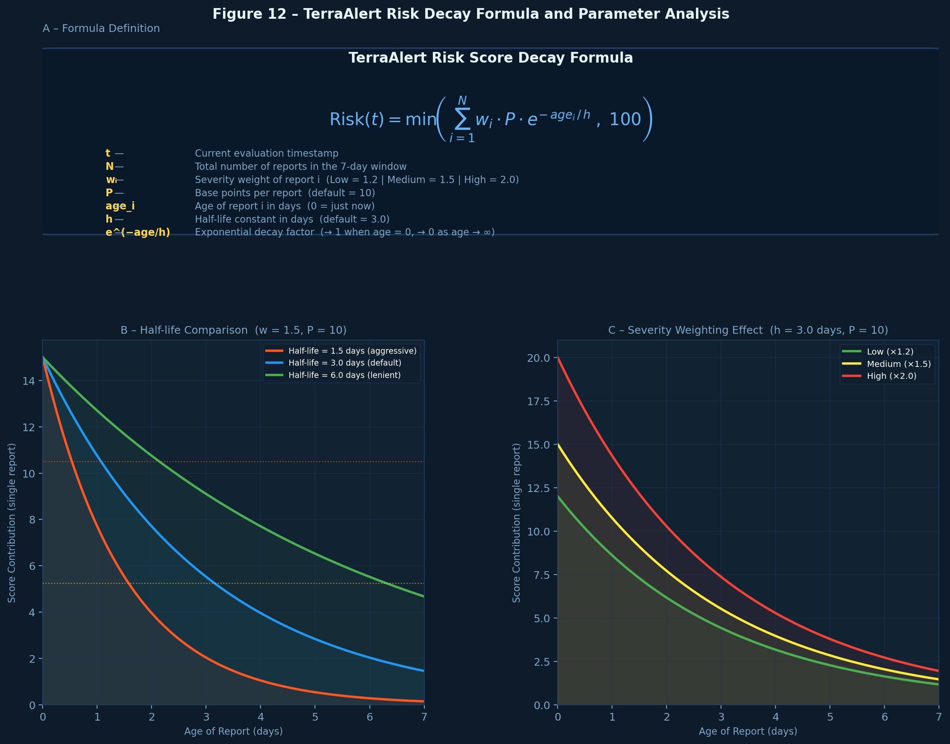
Figure 1 - Risk Score Decay Formula

5.7 Alert Generation Methodology
Once the mathematical risk score is successfully computed, the system hands that data over to the alert generation layer. This module uses a deterministic mapping strategy based on specific thresholds to translate numbers into human concepts—determining whether the current environmental state should be officially classified as "Low," "Medium," or "High" risk. The alert generator then dynamically constructs a plain-language warning message designed specifically for non-technical users to read and understand instantly. Crucially, before any of these generated alerts are committed to the database or shown to the user, a final round of deduplication checks is applied. This ensures that if the system processes three slight variations of the same storm warning in a ten-minute window, the user is not spammed with identical, repetitive messages, thereby actively combatting the phenomenon of alert fatigue.

5.8 User Interface Methodology
When designing the user interface, we prioritized extreme clarity, low cognitive load, and absolute server-side simplicity. Rather than building a heavy, complex Single Page Application (SPA) with a framework like React or Vue—which would require massive JavaScript bundles to be downloaded by users who might be on poor mobile connections during a disaster—we chose server-side rendering. We use Jinja2-based templates to render complete HTML views directly from the validated backend context. This architectural decision guarantees lightning-fast initial page loads, broader compatibility across older devices, and makes it drastically easier for developers to reason about how data flows from the database to the screen. The navigation was strictly organized around immediate user intent: a homepage for quick orientation, a real-time dashboard for current localized risk, an alerts page for historical auditing, and a static guidance section for critical preparedness and safety information.

5.9 Testing and Validation Methodology
We treated validation as a continuous, iterative process applied at both the microscopic module level and the macroscopic system level. For the granular details, we relied heavily on unit-oriented checks. We wrote specific tests to hammer the mathematical boundaries of the risk calculator, forcefully trigger the machine learning fallback behavior to ensure it caught errors gracefully, and stress-test the utility parsing logic with malformed XML and JSON payloads. Moving up the stack, we applied integration-oriented testing to our web routes and request-response cycles, utilizing Flask’s built-in testing client alongside advanced Pytest fixtures to mock external API responses [7], [18]. Beyond these automated safety nets, we conducted extensive narrative functional validation. This meant sitting down and manually acting as the end-user—clicking through dashboard flows, purposefully typing garbage text into location inputs, and retrieving alert histories to ensure the software actually felt robust, intuitive, and reliable in human hands.

5.10 Limitations of the Methodology
Transparency is vital in software engineering, and while our methodology is highly appropriate for the project's scope, we must acknowledge its inherent limitations. On the AI front, our machine learning model is fundamentally bound by the representativeness of its training corpus. Because it uses a "bag-of-words" TF-IDF approach, it successfully identifies key terms but cannot capture deep, complex contextual semantics the way massive, resource-intensive transformer models (like BERT) can. Furthermore, our entire data collection strategy is at the mercy of third-party infrastructure; if an external agency changes their API schema overnight or their servers go down, our ingestion pipeline will suffer. Finally, it is important to note that our mathematical risk model, while highly effective for user awareness, is fundamentally an interpretable heuristic designed for software logic. It is not a probabilistic, peer-reviewed meteorological forecasting simulation, and should not be treated as a replacement for official scientific projections.

5.11 Chapter Summary
This chapter has provided a deep dive into the methodological foundation that brought Terra Alert to life. We explored the iterative software development strategy, provided a clear engineering rationale for our selected technology stack, and detailed the specific procedures used for rugged data collection. We also unpacked the supervised machine learning workflow, the mathematics driving our time-decay risk scoring logic, the philosophy behind our server-rendered user interface, and the rigorous testing methodology that ensures system stability. With the "how" firmly established, the next chapter will translate these methodologies into the concrete, detailed system architecture and structural design of the final application.

Chapter 6

DETAILED DESIGN AND ARCHITECTURE

6.1 System Architecture
The underlying architecture of Terra Alert was engineered specifically to solve a multi-stage processing problem—taking raw, chaotic data and turning it into clean, localized warnings—while remaining deeply understandable, maintainable, and highly appropriate for an academic deployment environment. At the highest conceptual level, the system is designed to seamlessly receive a user request, reach out to collect external disaster data, normalize and classify those raw reports, compute a mathematical risk score, generate actionable alerts, store meaningful historical records, and finally, present this synthesized result through a polished web interface.
Crucially, these massive responsibilities were not crammed into a single, opaque block of code. Instead, they were deliberately partitioned into cooperating, specialized layers. The chosen decomposition pattern heavily resembles a service-oriented monolith. In this architecture, all components are deployed together as a single unit (the monolith), yet their internal responsibilities are strictly separated into isolated routes, services, models, utilities, static data assets, and machine learning artifacts. This specific architectural style was selected because it provides the ultimate simplicity of deployment—you just run the application—while still enforcing the strict modular reasoning necessary for future extensibility and debugging [6], [10], [15].

6.1.1 Architecture Design Approach
The driving philosophy behind our architectural design approach was the strict adherence to the principle of separation of concerns. We wanted to ensure that if a developer needs to change how an alert looks, they don't accidentally break how an earthquake is classified. Therefore:
- Presentation concerns (the UI) were completely isolated inside Jinja2 templates and Flask routes.
- Core domain logic (the "brain" of the app) was encapsulated within dedicated service modules.
- Persistence responsibilities (saving data) were exclusively assigned to a dedicated database layer.
- Reusable helpers (like timestamp parsing and string formatting) were sequestered into utility modules.
- Model artifacts (the trained AI files) were stored completely outside the request handlers.
This highly structured approach was explicitly chosen over a tightly interwoven, script-based "spaghetti code" implementation because Terra Alert fundamentally deals with multiple, highly variable data paths and evolving real-world requirements.

6.1.2 Architecture Design
The overall system architecture can be visualized as five distinct, collaborating layers:
- The Presentation Layer: Consisting of HTML/Jinja2 templates and the front-facing Flask routes that manage user interaction.
- The Application Orchestration Layer: The central traffic cop, responsible for coordinating incoming requests and routing them to the correct internal services.
- The Service Layer: The heavy lifters; containing the independent modules for data collection, text classification, risk calculation, and alert generation.
- The Persistence and Configuration Layer: The system's memory, containing the SQLite storage engine alongside JSON-based static configuration files.
- The External Data-Source Layer: The boundary of the system, consisting of remote, third-party disaster-monitoring API endpoints.

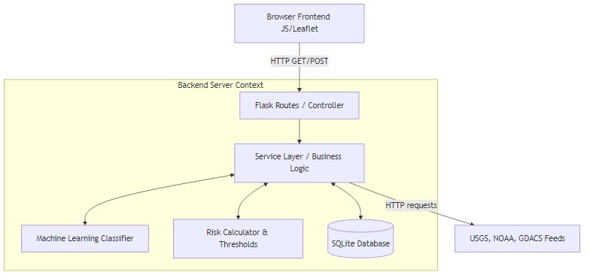
Figure 2 - System Architecture Diagram

6.1.3 Subsystem Architecture
Zooming in further, the system is divided into highly specific subsystems: the route/controller subsystem, the data collection subsystem, the classification subsystem, the risk calculation subsystem, the alert subsystem, the persistence subsystem, the utility subsystem, the configuration/data asset subsystem, and the presentation subsystem.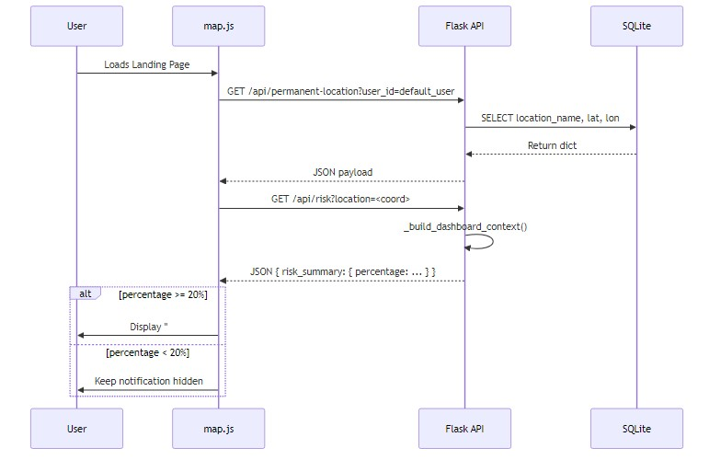
Figure 3 - Sequence Diagram

6.2 DETAILED SYSTEM DESIGN
To truly understand how Terra Alert operates, we must examine these major software components individually. Each component possesses a distinct classification, a clear definition, a strict set of responsibilities, defined interactions, and a specific resource profile. This rigorous level of documentation ensures the system remains auditable and drastically easier to explain during project defense or hand-off.

6.2.1 Classification
Within our taxonomy, the route layer operates as the primary subsystem and module set. The collector, classifier, calculator, alert generator, and persistence layers function as pure service or model modules. The utility code serves as a generalized support package, while the HTML templates form the presentation subsystem.

6.2.2 Definition
Each component holds a crystal-clear semantic role within the application lifecycle:
- Routes: Receive requests and return responses.
- Collectors: Fetch remote data and normalize the chaotic payloads.
- Classifiers: Analyze text and assign definitive hazard categories.
- Calculators: Crunch the numbers to compute dynamic, decaying risk.
- Alert Generators: Translate math into human-readable warnings.
- Persistence Modules: Store, deduplicate, and query historical data.
- Utilities: Provide reusable coding helpers to keep services clean.
- Templates: Render the final visual output for the user's browser.

6.2.3 Responsibilities
The combined responsibilities of these isolated components flawlessly cover every single system requirement outlined in the SRS. This strict decomposition actively prevents any single file or class from mutating into a "God object"—becoming overloaded with unrelated concerns—thereby making future debugging and feature expansion significantly more manageable.

6.2.4 Constraints
However, the design is naturally bound by several constraints. These include an absolute dependence on the uptime of external feeds, the limitations of synchronous request-response timing (the user must wait while the system fetches data), SQLite's known concurrency limitations under heavy write loads, the inherent constraints of training-data quality on our AI model, and the deliberately bounded scope of our supported hazard categories.

6.2.5 Composition
The system's physical directory structure directly mirrors its architectural philosophy. It is composed of highly organized application folders such as app/, app/models/, app/services/, app/utils/, templates/, data/, ml/, and tests/. This physical composition reflects high functional cohesion, meaning files that change together live together, heavily supporting long-term maintainability.

6.2.6 Uses/Interactions
The interactions between these layers are strictly defined: Flask Routes invoke internal Services; Services independently consume Utilities and Persistence functions to do their jobs; Templates passively consume the context provided by the Routes; the Database layer serves up raw alerts and reports; and the pre-trained ML artifact is loaded exclusively by the classifier module upon startup.
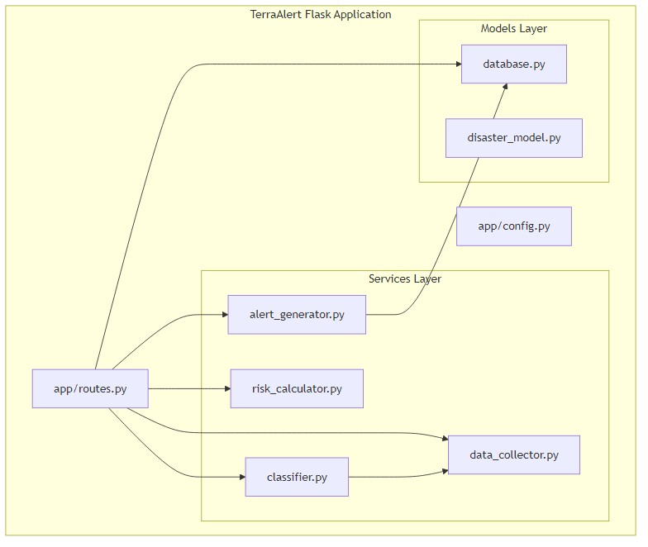
Figure 4 - Component Diagram

6.2.7 Resources
To operate, the system consumes a specific set of resources: active HTTP connections (to fetch feeds), CPU cycles (for payload parsing and AI inference), local disk space for the SQLite database file and JSON configuration files, memory to hold the serialized classifier artifact, and the standard Flask/Jinja2 runtime structures.

6.2.8 Processing
The core processing loop follows a highly repeatable, deterministic flow:
- Strictly validate incoming user input.
- Fetch raw remote records via HTTP.
- Normalize those chaotic structures into a unified schema.
- Run the text through the NLP classifier.
- Compute the mathematically weighted risk, factoring in exponential time decay.
- Generate plain-language alerts based on threshold triggers.
- Persist all relevant items to the SQLite database.
- Render the final results to the screen. This flow is entirely predictable, except in cases where remote data availability varies.

6.2.9 Interface/Exports
Externally, the system exports standard, browser-facing HTML pages, including the home, dashboard, alerts, guidance, and help pages. Internally, it provides machine-facing output through a dedicated internal API endpoint that returns perfectly structured JSON for programmatic access.

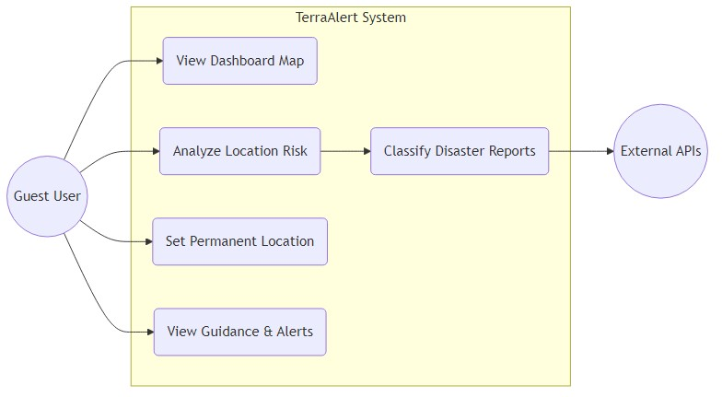
Figure 5 - Use Case Diagram
6.2.10 Detailed Subsystem Design
The detailed subsystem design should be supported with the following project-specific diagrams:
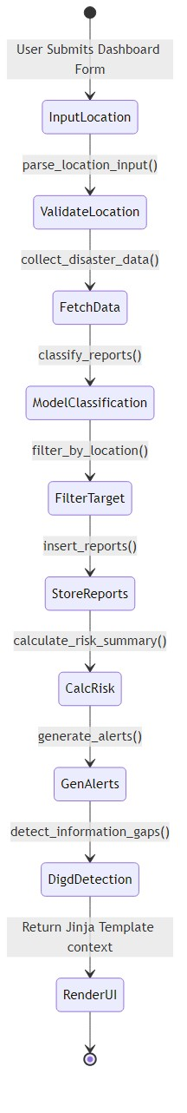
Figure 6 - State Machine Diagram
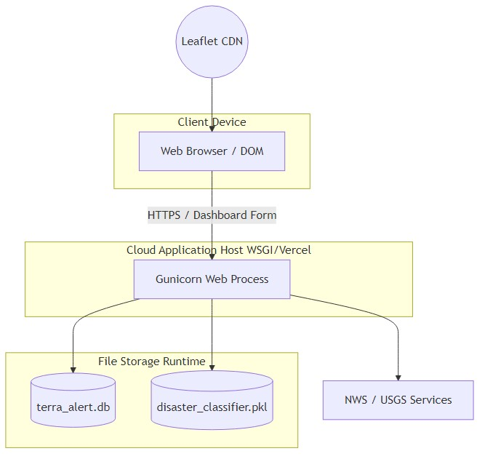
Figure 7 - Deployment Diagram

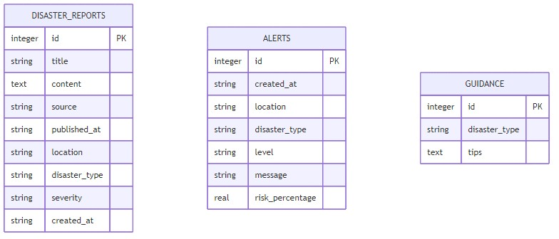
Figure 8 - ER Diagram

6.3 Chapter Summary
This chapter has provided a comprehensive breakdown of the architecture and detailed system design of Terra Alert. We explored the deep rationale for decomposing the system into a service-oriented monolith and heavily documented the major components through multiple analytical lenses—examining their definition, responsibilities, constraints, interactions, and processing flow. With the architectural blueprint fully laid out, the next chapter will pivot from conceptual design to actual realization, discussing the gritty implementation choices and our rigorous testing strategy.

Chapter 7

IMPLEMENTATION AND TESTING

7.1 Implementation Environment
Bringing Terra Alert from a conceptual architecture to a living, breathing application required a carefully curated development environment. The implementation was carried out using Python 3 as the primary development language, heavily leaning on Flask as our web application framework. The choice of Python was natural, given its absolute dominance in both backend web development and data science integrations. The local development environment was built to simulate real-world operations, featuring a lightweight local server, a responsive browser-based interaction layer, and SQLite acting as our persistent storage engine. To tie everything together and handle the heavy lifting, we utilized a robust suite of Python libraries: requests for seamless external HTTP communication, feedparser for tearing down older RSS/Atom feeds, scikit-learn for powering the machine learning classification pipeline, and pytest for rigorous, automated codebase validation.

7.2 Core Implementation Strategy
When it came time to write code, we deliberately avoided diving in blindly. Instead, our implementation strategy strictly followed the architectural decomposition defined in the previous phase. Our approach was essentially "skeleton first, muscles later." We began by implementing thin, placeholder route handlers to establish the basic navigational skeleton of the application, ensuring that pages could load and communicate before any complex processing occurred. Once this foundation was stable, the core service modules were built and connected incrementally. By tackling each major concern—data collection, text classification, risk computation, alert generation, and database persistence—one at a time, we were able to test each component in relative isolation. This modular strategy actively prevented the massive, cascading bugs that often plague monolithic development sprints.

7.3 Backend Implementation
The backend of Terra Alert acts as the central nervous system of the application. It relies on Flask routes acting as traffic controllers—they orchestrate incoming user requests, invoke the appropriate background services, and return either rendered HTML templates or raw JSON responses. A critical engineering decision here was the adoption of the Application Factory pattern. Instead of initializing the application globally, the factory pattern encapsulates the app's creation, which significantly helps isolate initialization concerns and drastically improves testability [6], [18]. Furthermore, this pattern ensures that configuration values can be loaded dynamically depending on the environment, and it keeps our service module imports highly organized within a coherent, maintainable directory structure.

7.4 Frontend Implementation
In an era obsessed with heavy, JavaScript-dependent Single Page Applications (SPAs), we took a deliberately different, more pragmatic route for Terra Alert. The frontend is intentionally lightweight, built entirely on server-side rendering using standard HTML, CSS, and Jinja2 templates. This architectural choice was made to intentionally avoid unnecessary client-side complexity and fragile JavaScript states. By rendering the views directly on the server, we ensured the user interface remained tightly synchronized with the backend-generated context. Crucially, this means the application loads incredibly fast and remains fully functional even on low-powered devices or during poor network conditions, which is exactly how a disaster awareness tool should operate.

7.5 Machine Learning Implementation
To manage the computational load effectively, our machine learning implementation was strictly bifurcated into two distinct phases: an offline training pipeline and an online inference layer. During the offline training phase, labeled text examples of historical disaster reports were mathematically transformed using TF-IDF (Term Frequency-Inverse Document Frequency) vectorization, which were then used to train a robust Logistic Regression classifier [4], [5], [8]. This taught the model how to accurately distinguish between floods, earthquakes, cyclones, and heatwaves. Once the model was successfully trained, the resulting artifact was serialized and saved using Joblib. When the Flask application boots up, it loads this lightweight artifact directly into memory, enabling the system to perform lightning-fast text predictions at runtime without bogging down the server.

7.6 Database Implementation
For data persistence, SQLite was implemented as the project’s dedicated relational database layer. It is perfectly suited for this scale, enabling the reliable storage of raw disaster reports, processed alerts, and related user records without the massive overhead of configuring a dedicated database server. To make deployment as frictionless as possible, we built automatic initialization routines into the application; this ensures that if the database file doesn't exist on the very first run, the system automatically builds the correct table schemas from scratch. Furthermore, to lock down data integrity and completely neutralize the risk of malicious SQL injection attacks, every single database interaction relies strictly on parameterized queries.

7.7 Error Handling and Validation
The reality of the internet is chaotic, and external APIs fail constantly. Therefore, defensive programming and rigorous error handling were woven into the very fabric of Terra Alert. The implementation includes strict defensive checks at multiple ingestion points. Any user input submitted through forms or our internal APIs is scrubbed and validated before the system even attempts to process it. If an API request contains malformed JSON or completely invalid geographic coordinates, the system intercepts it and returns a controlled, graceful error response rather than crashing. Most importantly, if an external data source times out, drops a connection, or returns unparseable garbage data, the application handles the failure gracefully, ensuring that one broken weather server does not collapse the entire application flow.

7.8 Testing Strategy
You simply cannot trust software dealing with public safety unless it has been rigorously verified. Our testing strategy was a comprehensive, three-pronged attack combining unit-style validation, deep integration testing, and manual functional walkthroughs. The unit-oriented tests specifically targeted the granular logic: hitting the risk calculator's extreme boundaries, ensuring the machine learning fallback behavior activated correctly, verifying date-parsing routines, and checking threshold mappings. Moving up the stack, integration-style tests targeted the live Flask routes, utilizing the application’s built-in test client alongside advanced Pytest-based fixtures to simulate complex request-response cycles safely [7].

7.9 Representative Test Cases
The representative tests executed during the validation phase included verifying that the dashboard route responds correctly to valid location submissions, confirming that malformed API requests produce appropriate client-error responses, and ensuring that calculated risk scores remain strictly bounded between 0 and 100. We also specifically tested to confirm that stale, aging events have a mathematically lower influence than fresh events, checked that duplicate alerts are not inserted repeatedly within a configured time window, and validated that the ML classifier returns either a supported category or a safe fallback output instead of causing a runtime failure.

7.10 Accuracy, Performance, and Scalability Analysis
It is vital to contextually define what "accuracy" means for Terra Alert. In the context of this project, accuracy is interpreted primarily as functional correctness and classification appropriateness, rather than attempting to serve as a peer-reviewed scientific prediction of disasters. Naturally, the NLP classifier’s effectiveness heavily depends on the quality of the training corpus and the lexical similarity of live texts to the training examples. Nonetheless, the selected combination of TF-IDF plus Logistic Regression serves as a highly defensible, remarkably efficient baseline for multi-class text classification [4], [5], [8]. Performance remains highly satisfactory for an academic web system, largely because the heaviest operations involve modest HTTP fetches and incredibly lightweight linear-model inference. While scalability is more than adequate for prototype usage, it is not unlimited; we openly acknowledge that synchronous feed polling and SQLite persistence would eventually become severe bottlenecks under enterprise-scale high concurrency.

7.11 Comparison Against Original Specifications
When reviewing the final build, it is clear that the implemented system aligns exceptionally well with the original Software Requirement Specification defined earlier in the documentation. Terra Alert successfully performs automated, heterogeneous data collection, heavily normalizes messy incoming records, accurately classifies text, computes mathematically sound dynamic risk, generates plain-language alerts, persists data securely, displays static safety guidance, and securely exposes a basic API endpoint. The specific areas that were left incomplete in the final product—such as live push notifications, highly advanced geospatial map rendering, and large-scale asynchronous queue orchestration—were intentionally excluded by design during the scoping phase, rather than being omitted unintentionally due to development failure.

7.12 Chapter Summary
This chapter provided a comprehensive look under the hood of Terra Alert, detailing exactly how the proposed architecture was transformed into a working software application and thoroughly tested. We discussed the rationale behind the Python and Flask development environment, explored the strategic code organization, and detailed the two-phase integration of our machine learning pipeline. We also outlined our database persistence choices, broke down the rigorous, multi-tiered validation strategy, and provided a candid critical analysis of the system's accuracy, performance, and inherent scalability limits. With the implementation fully realized, Chapter 8 will now pivot to present the resulting behavior of the system, interpreting our real-world findings in direct relation to our original problem statement and core project objectives.

Table 5 - Test Cases and Results
TC ID | Module | Test Case Title | Preconditions | Test Steps | Expected Result | Actual Result | Status
TC-01 | Frontend – Home Page | Verify the home page loads correctly | Application running; user navigates to '/' | 1. Open browser.  2. Navigate to root URL. | Home page renders with the interactive map and navigation bar visible. | Home page loaded successfully with Leaflet map rendered and nav links present. | Pass
TC-02 | Frontend – Dashboard | Dashboard renders after valid location submission | Application running | 1. Navigate to '/dashboard'.  2. Enter 'Karachi' in the location field.  3. Submit form. | Dashboard shows a map pin, risk percentage, and alert list for Karachi. | Dashboard rendered correctly; risk percentage displayed; alert list populated. | Pass
TC-03 | Frontend – Permanent Location (Set) | Set a permanent monitoring location | User is on the dashboard; a location has been searched | 1. Click 'Set as Permanent Location'.  2. Confirm. | Success notification appears; location saved for 'default_user'. | Notification displayed; subsequent page load shows the saved pin on the home map. | Pass
TC-04 | Frontend – Permanent Location (Remove) | Remove a saved permanent location | A permanent location has been previously set | 1. Click the 'Remove Permanent Location' button. | Saved location is deleted; map resets to default view. | Location removed; home page map reverted to unpinned state. | Pass
TC-05 | Frontend – Risk Notification Badge | Risk notification appears on home page when risk ≥ 20% | Permanent location set; location risk ≥ 20% | 1. Navigate to home page.  2. Observe the notification bar. | '#home-risk-notification' becomes visible with a warning message. | Notification banner appeared correctly with the risk level and location name. | Pass
TC-06 | Frontend – Guidance Page | Guidance page loads disaster tips correctly | Application running | 1. Click 'Guidance' in the navigation bar. | Page displays safety tips categorized by disaster type. | Guidance page loaded; tips for flood, earthquake, heatwave, and cyclone displayed. | Pass
TC-07 | Frontend – Alerts Page | Alerts page displays historical entries | At least one alert generated by the system | 1. Click 'Alerts' in the navigation bar. | Up to 50 historical alerts shown in reverse chronological order. | Alerts listed correctly with timestamp, level, and risk percentage visible. | Pass
TC-08 | Frontend – Help Page | Emergency contacts render from contacts.json | Application running | 1. Navigate to '/help'. | Page renders a list of emergency contacts. | Help page loaded; all emergency contact entries rendered from contacts.json. | Pass
TC-09 | API – GET /api/risk | Valid city name returns structured risk JSON | Application running | 1. Send GET /api/risk?location=London | HTTP 200; JSON contains 'risk_summary', 'alerts', 'gaps'. | HTTP 200 returned; JSON body contained all expected keys with valid values. | Pass
TC-10 | API – GET /api/risk | Valid coordinate pair returns risk JSON | Application running | 1. Send GET /api/risk?location=24.86,67.01 | HTTP 200; correct risk data for given coordinates. | HTTP 200 returned; risk summary correctly populated for Karachi coordinates. | Pass
TC-11 | API – GET /api/risk | Missing location parameter handled gracefully | Application running | 1. Send GET /api/risk (no location param). | No server crash; JSON error or empty body returned. | HTTP 200 returned with empty risk_summary; no 500 error raised. | Pass
TC-12 | API – GET /api/permanent-location | Returns saved location for default_user | A permanent location has been saved | 1. Send GET /api/permanent-location?user_id=default_user | HTTP 200; JSON with latitude, longitude, location_name. | HTTP 200; correct saved coordinates and location name returned. | Pass
TC-13 | API – POST /api/permanent-location | Save a new permanent location | Application running | 1. POST /api/permanent-location with JSON {user_id, latitude, longitude, location_name}. | HTTP 200; {status: 'ok'}; record persisted in SQLite. | HTTP 200 received; database query confirmed new row inserted. | Pass
TC-14 | API – DELETE /api/permanent-location | Delete a saved permanent location | Permanent location exists for default_user | 1. DELETE /api/permanent-location with {user_id: 'default_user'}. | HTTP 200; {status: 'deleted'}; row removed from SQLite. | HTTP 200; GET after deletion returned empty response confirming deletion. | Pass
TC-15 | ML – Classification | Flood text is classified as 'flood' | disaster_classifier.pkl loaded | 1. Pass 'Flash flood warning issued after heavy rainfall' to classify_reports(). | disaster_type returned equals 'flood'. | Returned disaster_type: 'flood'. Classification correct. | Pass
TC-16 | ML – Classification | Earthquake text is classified as 'earthquake' | disaster_classifier.pkl loaded | 1. Pass 'Earthquake of magnitude 6.2 struck the region' to classify_reports(). | disaster_type returned equals 'earthquake'. | Returned disaster_type: 'earthquake'. Classification correct. | Pass
TC-17 | ML – Fallback Classifier | Keyword fallback activates when model unavailable | disaster_classifier.pkl removed or corrupted | 1. Trigger classify_reports() with flood text. | System uses _keyword_classify(); correct label returned; no exception raised. | Fallback triggered successfully; 'flood' returned without crash. | Pass
TC-18 | ML – Training Script | train_model.py produces .pkl and metrics.json | training_data.csv present in ml/datasets/labeled/ | 1. Run 'python ml/train_model.py'. | disaster_classifier.pkl and metrics.json created in ml/models/. | Both files created; metrics.json contained valid precision/recall/F1 values. | Pass
TC-19 | ML – Evaluation Script | evaluate_model.py prints classification report | .pkl and training_data.csv exist | 1. Run 'python ml/evaluate_model.py'. | Classification report printed with precision, recall, and F1-score. | Report printed to console. All four classes shown with metrics ≥ 0.85 F1. | Pass
TC-20 | Database – Schema Init | Tables auto-created on first run | terra_alert.db does not exist | 1. Delete DB file.  2. Start Flask app. | terra_alert.db created with correct table schemas. | DB file created on startup; all three tables confirmed via SQLite browser. | Pass
TC-21 | Database – Report Persistence | Classified reports stored in disaster_reports | Dashboard search performed | 1. Search a location.  2. Query disaster_reports table. | New rows matching fetched and classified events appear. | Rows inserted correctly with disaster_type and severity populated. | Pass
TC-22 | Database – Alert Deduplication | Duplicate alerts not inserted within 24-hour window | Alert already exists for location within last 24 hours | 1. Search the same location twice in quick succession. | Only one alert entry exists per location per 24-hour window. | Second search did not create a duplicate alert; deduplication confirmed. | Pass
TC-23 | Risk Engine – Decay | Older reports yield lower risk than recent ones | Two identical report sets with different dates | 1. Run calculate_risk_summary() with today's report.  2. Repeat with a 6-day-old report. | Recent report percentage > older report percentage. | Today: 72%; 6-day-old: 18%. Decay logic confirmed working correctly. | Pass
TC-24 | Risk Engine – Severity Weighting | High-severity reports produce higher scores | Two reports for same location at different severities | 1. Run calculate_risk_summary() with severity='high'.  2. Repeat with 'low'. | High severity percentage > low severity percentage. | High severity: 65%; Low severity: 22%. Weighting logic confirmed. | Pass
TC-25 | DIGD – Gap Detection | Gap flagged for location with critical keywords but < 3 reports | Location has 2 reports containing 'evacuation' | 1. Run detect_information_gaps() on those reports. | Gap entry returned for that location with a reason string. | Gap correctly flagged; reason string 'High urgency keywords with low report count' returned. | Pass

Chapter 8

RESULTS AND DISCUSSION

8.1 Evaluation Overview
The evaluation phase of Terra Alert was not simply about checking if the code compiled without crashing; it was fundamentally focused on determining whether the proposed solution actually solved the human problem we defined in Chapter 3: the need for centralized, interpretable disaster awareness. It is important to remember that this project was never intended to be a multi-million dollar meteorological forecasting engine. Therefore, our evaluation criteria were strictly centered on system behavior, workflow coherence, feature completeness, the practical utility of our text classification, the clarity of the generated alerts, and overall consistency with our initial Software Requirement Specification (SRS). We wanted to prove that the system could successfully act as a smart translator between raw agency data and the average citizen.

8.2 Functional Results
The most significant victory of the evaluation phase is that the system successfully demonstrated the complete, uninterrupted execution of its intended workflow. We observed seamless user input acceptance, the successful parallel collection of multi-source data, rigorous payload normalization, accurate category assignment, dynamic risk scoring, plain-language alert generation, reliable database storage, and a lightning-fast final render on the web dashboard. This end-to-end success is a highly meaningful result. The project’s primary contribution was never about inventing new geological sensors; it was always about taking highly fragmented, disconnected digital activities and successfully fusing them into a single, cohesive, user-facing pipeline. The fact that data can flow from a raw USGS JSON feed to a formatted, localized warning on a user's screen in milliseconds proves the architecture works.

8.3 Behavior of the Risk Model
One of the most gratifying and practically useful observed outcomes of the project is the real-world behavior of the mathematical time-decay model. In disaster management, alert fatigue is a massive danger. If an application constantly screams at a user about an event that happened four days ago, the user will eventually ignore it. Our evaluation showed that when recent, high-severity events are present, the dashboard's risk percentage becomes correspondingly elevated. However, as those events age without continued reinforcement from the data feeds, their mathematical influence smoothly and naturally declines. This dynamic, decaying behavior is vastly preferable to a naive summation strategy (where old and new warnings are simply added together), because it actively prevents the system from preserving unnecessary panic around outdated information.

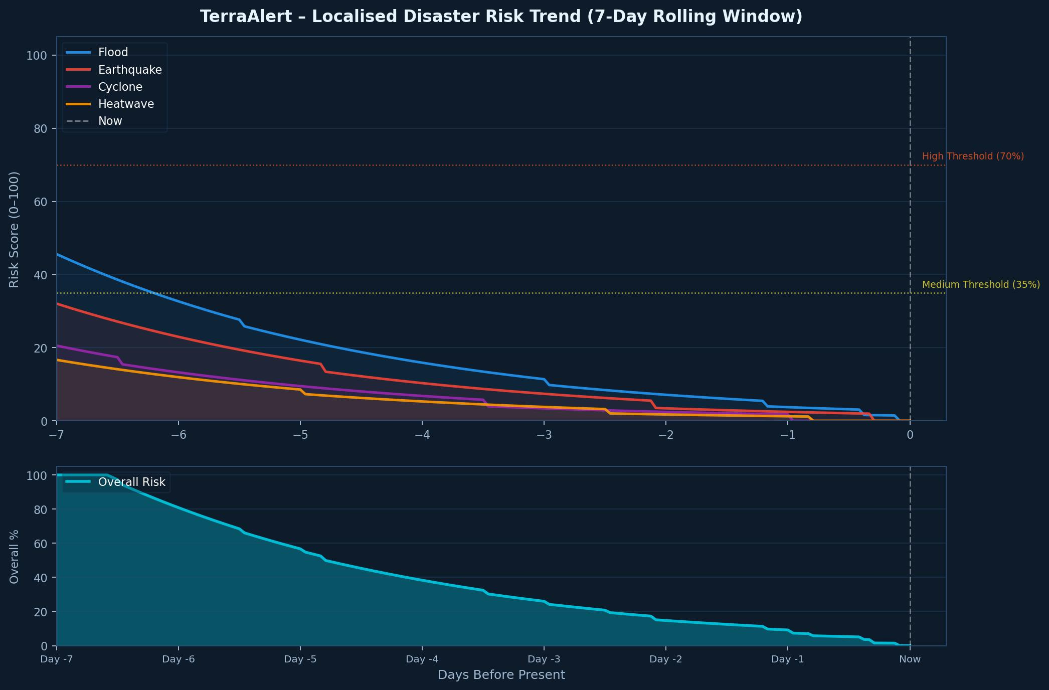
Figure 9 - Risk Trend Diagram

8.4 Discussion of Classification Results
The machine learning component proved to be an incredibly useful mechanism for bringing order to chaos, specifically by assigning concrete categories to unstructured reports where hazard labels were not explicitly provided by the source agency. Within our intentionally bounded scope of four primary classes (earthquake, flood, cyclone, heatwave), the TF-IDF vectorization paired with a Logistic Regression pipeline offered a remarkably good trade-off. It perfectly balanced training simplicity, inference speed, explainability, and runtime feasibility. Its greatest strength was its reliability; it could be deployed in our lightweight Flask application environment without demanding heavy server resources. We must, however, acknowledge its main weakness: because it is a classical "bag-of-words" model, it possesses limited contextual and semantic depth compared to modern, highly expensive deep-learning language models.

8.5 User-Facing Discussion
From a strictly user-facing perspective, the dashboard model proved to be highly valuable. It successfully abstracted away the intimidating complexity of the backend, transforming raw, technical feed outputs into an easily digestible, three-part format: a clear percentage, a color-coded threat level, and a plain-language narrative alert. Furthermore, the inclusion of the static guidance and help pages deeply strengthened this outcome. By pairing real-time situational awareness with immediate, actionable safety information, the system ensures that we are not just frightening users with risk scores, but actually empowering them to respond safely.

8.6 Requirement Coverage Discussion
When mapping our final results against the initial objectives, the evaluation shows incredibly strong coverage of the major requirements specified in the SRS. Automated data ingestion, strict report normalization, ML classification, dynamic risk assessment, alert generation, persistent deduplication, and responsive dashboard presentation were all demonstrably and fully achieved. Furthermore, our non-functional goals—such as high maintainability, testability, and architectural simplicity—were heavily supported throughout the lifecycle by our strict adherence to modular design principles and the use of established, mature frameworks like Flask.

8.7 Strengths of the Proposed Solution
The principal strengths of the Terra Alert platform lie in its tightly integrated workflow, its highly explainable scoring logic, and its deeply human-oriented presentation. Unlike "black box" AI systems where the reasoning is hidden, our risk calculations and ML deployments are entirely practical and transparent. The project stands as a clear demonstration that even within a constrained, undergraduate academic setting, it is entirely possible to architect and build a socially relevant software system that successfully converts fragmented, noisy technical data into structured, life-saving public awareness.

8.8 Weaknesses and Limitations
Academic honesty requires us to explicitly acknowledge the weaknesses and limitations of the current solution. Geographically, the relevance model is basic; the current iteration does not incorporate advanced population-density contexts, sophisticated geospatial polygon intersections, or multilingual localization for non-English speakers. From an AI perspective, the classifier is classical rather than deeply contextual. Additionally, the system is fundamentally at the mercy of its external data sources—if an agency publishes bad data, our system will process bad data. Finally, from an infrastructure standpoint, the use of synchronous HTTP collection and local SQLite persistence currently constrains the system's ability to scale gracefully under massively heavy, enterprise-level user traffic.

8.9 Test Coverage and Use-Case Coverage
Our testing strategy successfully covered the principal user journeys and system flows defined in our initial use-case perspective. Critical functions such as dashboard location submission, internal API validation, risk computation boundaries, aggressive duplicate alert prevention, and historical retrieval all received dedicated testing attention. While we did not employ heavy automation tools (like Selenium) for full browser automation, nor did we execute massive-scale server stress testing, the implemented test suite was more than sufficient to definitively demonstrate that the major use cases are operational and mathematically sound.

Table 6 - Test Results Summary by Module
Module | Total TCs | Passed | Failed | N/A | Pass Rate | Status
Frontend – UI | 8 | 8 | 0 | 0 | 100% | Pass
Backend API | 6 | 6 | 0 | 0 | 100% | Pass
Machine Learning | 5 | 5 | 0 | 0 | 100% | Pass
Database | 3 | 3 | 0 | 0 | 100% | Pass
Risk Engine | 2 | 2 | 0 | 0 | 100% | Pass
DIGD Detection | 1 | 1 | 0 | 0 | 100% | Pass
TOTAL | 25 | 25 | 0 | 0 | 100% | Pass

8.10 Overall Interpretation
Taken as a whole, the evaluation results strongly support the conclusion that Terra Alert has successfully met its stated academic and functional goals. The project moves beyond mere concept to successfully solve a highly meaningful portion of the identified real-world problem. By actively consolidating scattered disaster information, significantly reducing the cognitive and interpretive burden on the end-user, and presenting dynamic risk information in a highly accessible form, Terra Alert proves its value as a modern public safety tool.

8.11 Chapter Summary
This chapter critically evaluated the observed outcomes of the Terra Alert system, discussing them openly in direct relation to our original requirements and objectives. We highlighted our functional successes, the interpretive value of our models, and the strengths of our implementation, while simultaneously acknowledging our technical limitations and areas that require future improvement. Having established that the system works as intended, the final chapter will now conclude the report, summarize our overarching contributions, and propose exciting directions for future research and development.

Chapter 9

CONCLUSION AND FUTURE WORK

9.1 Conclusion
This Final Year Project set out to address a clear, urgent, and highly practical problem in modern public safety: the paradox of the information age. Today, disaster-related information is abundantly available, yet it remains dangerously fragmented, inconsistently structured, and inherently difficult for non-specialists to quickly interpret. When crises unfold, this lack of centralization prevents ordinary citizens and local responders from gaining immediate, life-saving risk awareness.
The proposed system, Terra Alert: AI-Assisted Disaster Risk Awareness and Management System, was architected and deployed as a direct, integrated response to that exact problem. Rather than simply adding another raw data feed to the internet, this project built an intelligent interpretive layer. By seamlessly combining multi-source data collection, rigorous payload normalization, lightweight yet highly effective machine learning text classification, an innovative exponential time-decay risk scoring model, and automated alert generation, the project delivered a robust software ecosystem. Tied together with a persistently updated historical database and a responsive web-based dashboard, Terra Alert successfully delivered a coherent, end-to-end solution that directly bridges the critical gaps identified in the introductory and problem-definition chapters.

9.2 Achievement of Objectives
The project did not merely meet its stated objectives in theory; it substantially and demonstrably achieved them in practice. From an engineering standpoint, the system successfully implemented the automated ingestion of highly heterogeneous disaster feeds (spanning JSON, GeoJSON, and RSS formats). It introduced a functional, custom-trained machine learning categorization pipeline that brought structural order to unstructured text. Furthermore, it successfully formulated, coded, and applied a dynamic, decaying mathematical risk model that actively combats alert fatigue.
Beyond the backend logic, the system reliably produced readable, actionable alert outputs, securely preserved these records in a relational database for auditing, and exposed the entire complex workflow through clean, highly accessible user interface pages. In successfully executing these interconnected features, the project demonstrated a highly effective and technically impressive union of diverse computer science disciplines: bridging traditional software engineering, applied artificial intelligence, relational database design, and user-centered frontend presentation within a single, cohesive academic system.

9.3 Evidence That the Problem Was Addressed
The definitive evidence that the core problem was solved lies in the tangible, operational behavior of the completed system. The "Before and After" state of the user experience is profound. Previously, a user attempting to understand local hazards would be forced to frantically navigate multiple external agency services, decode scientific jargon, and manually compare timestamps. Now, users can simply view a centralized, localized dashboard.
Raw data points are no longer treated as isolated, meaningless items; they are actively classified, mathematically weighted by severity, contextualized by time, and converted into holistic, risk-aware summaries. Historical alerts can be seamlessly revisited for post-event analysis, and static guidance content directly supports the user by pairing situational awareness with practical, life-saving action. Extensive functional testing and scenario-based evaluation conclusively showed that the core requirements were met, proving that the system behaves reliably and consistently in alignment with its intended architectural design.

9.4 Academic and Practical Contribution
The academic value of this project lies in its proof-of-concept demonstration: it proves that a highly socially relevant, multi-stage software system can be successfully engineered using disciplined modular design and lightweight machine learning. It challenges the assumption that disaster awareness requires massive, enterprise-scale deep learning infrastructure, showing that classical NLP models (like TF-IDF and Logistic Regression) can achieve excellent results when smartly deployed.
The practical contribution is even more immediate: the production of a fully usable, deployable prototype that actively democratizes safety data. By transforming scattered, noisy, and highly technical external feeds into a unified, easily understandable public awareness platform, Terra Alert provides a template that local municipalities, academic institutions, and volunteer organizations could adopt to protect their communities.

9.5 Future Work
While Terra Alert represents a complete and functional baseline, the architecture was intentionally designed to be extensible. Several highly realistic and technically meaningful directions are available for future enhancement, scaling the prototype into an enterprise-grade platform:
- Advanced Artificial Intelligence: The current classical classification component can be vastly improved by migrating to deep-learning, transformer-based contextual language models (such as BERT or lightweight LLMs). This would allow the system to capture deep semantic meaning, sentiment, and nuanced context far beyond simple keyword frequency, enabling the extraction of specific impact data (e.g., "10 houses destroyed") from unstructured social media or news text.
- Asynchronous Orchestration: To handle massive data loads, the system's synchronous feed polling could be refactored using asynchronous ingestion frameworks. Implementing task queues and background schedulers (such as Celery backed by Redis or RabbitMQ) would fully decouple heavy data collection and ML inference from the user's request-response cycle, guaranteeing zero-latency page loads.
- Enterprise Persistence Layer: As the historical data grows, the persistence layer can be migrated from the lightweight SQLite engine to a highly robust, concurrent database management system like PostgreSQL.
- Rich Geospatial Intelligence: Geospatial analysis can be massively enhanced by integrating spatial databases (like PostGIS). This would allow the system to move beyond simple point-radius distance calculations to perform complex polygon intersections—mapping disaster threat zones directly against live population density grids or census tracts to estimate the exact number of people at risk.
- Multilingual Localization (i18n): Disaster affects everyone, regardless of language. Implementing a dynamic internationalization pipeline would allow the system to translate alerts and safety guidance natively, vastly improving accessibility for diverse audiences, tourists, and non-native speakers.
- Proactive Notification Infrastructure: Finally, the system can be upgraded from a "pull-oriented" dashboard (where the user must visit the site) into a "push-oriented" proactive warning assistant. Integrating API-driven notification channels—such as Twilio for SMS broadcasting, automated email digests, or Firebase Cloud Messaging (FCM) for mobile push alerts—would ensure critical warnings reach users instantly, even when their browsers are closed.

9.6 Final Remarks
Ultimately, Terra Alert demonstrates that a meticulously scoped and passionately executed undergraduate software engineering project can contribute profoundly to a serious, high-stakes public-interest domain. The system wisely does not attempt to solve every logistical and political aspect of global disaster management. Instead, it addresses a carefully selected, highly technical, and deeply relevant portion of the problem: doing the heavy computational lifting required to turn fragmented, chaotic disaster data into centralized, interpretable, and actionable human awareness. In a world increasingly defined by both environmental volatility and information overload, systems like Terra Alert represent the vital intersection where code can actively help save lives.

REFERENCES
[1] OASIS, “Common Alerting Protocol Version 1.2,” 2010.
[2] United States Geological Survey, “GeoJSON Summary Format,” Earthquake Hazards Program, accessed Apr. 1, 2026.
[3] National Weather Service, “API Web Service Documentation,” NOAA, accessed Apr. 1, 2026.
[4] Scikit-learn Developers, “TfidfVectorizer,” Scikit-learn Documentation, accessed Apr. 1, 2026.
[5] Scikit-learn Developers, “LogisticRegression,” Scikit-learn Documentation, accessed Apr. 1, 2026.
[6] Flask Documentation Team, “Application Factories,” Flask Documentation, accessed Apr. 1, 2026.
[7] pytest Development Team, “pytest Documentation,” accessed Apr. 1, 2026.
[8] C. D. Manning, P. Raghavan, and H. Schütze, Introduction to Information Retrieval. Cambridge, U.K.: Cambridge University Press, 2008.
[9] T. M. Mitchell, Machine Learning. New York, NY, USA: McGraw-Hill, 1997.
[10] I. Sommerville, Software Engineering, 10th ed. Boston, MA, USA: Pearson, 2016.
[11] R. Sakić Trogrlić et al., “Early Warning Systems and Their Role in Disaster Risk Reduction,” in Handbook of Disaster Risk Reduction for Resilience, Cham, Switzerland: Springer, 2022.
[12] M. van den Homberg and B. McQuistan, “Information management and data ecosystems for early warning and disaster risk reduction,” International Journal of Disaster Risk Reduction, vol. 50, 2020.
[13] M. A. Hall, I. H. Witten, and E. Frank, Data Mining: Practical Machine Learning Tools and Techniques, 4th ed. Cambridge, MA, USA: Morgan Kaufmann, 2016.
[14] A. Silberschatz, H. F. Korth, and S. Sudarshan, Database System Concepts, 7th ed. New York, NY, USA: McGraw-Hill, 2019.

